Explain NIST cloud computing

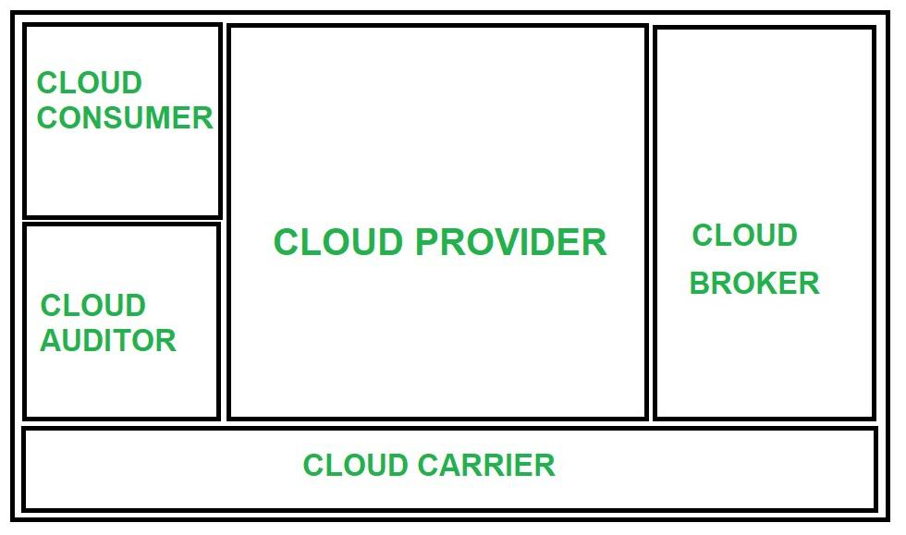

The notion of multiple parties using a shared cloud computing environment is highlighted in a

definition proposed by the U.S. National Institute of Standards and Technology (NIST):

Cloud computing is a model for enabling ubiquitous, convenient, on-demand network access to a shared pool of configurable computing resources (e.g., networks, servers, storage, applications, and services) that can be rapidly provisioned and released with minimal management ef ort or service provider interaction. The salient characteristics of cloud computing defi ned by the National Institute of Standards and Terminology (NIST) are (i) on-demand self-service, (ii) broad network access, (iii) resource pooling, (iv) rapid elasticity and (v) measured service.

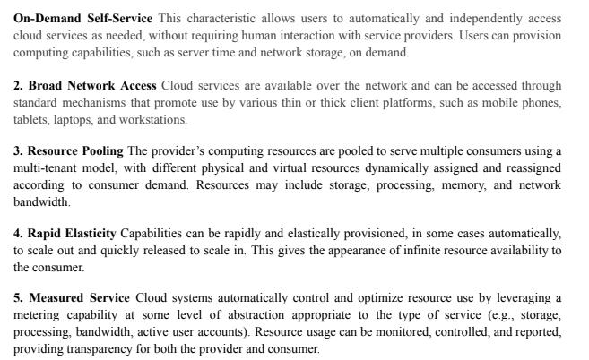



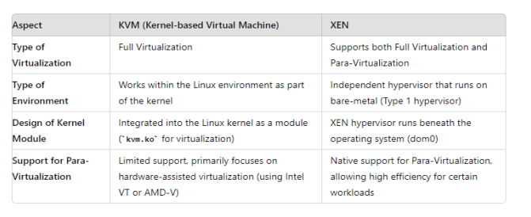

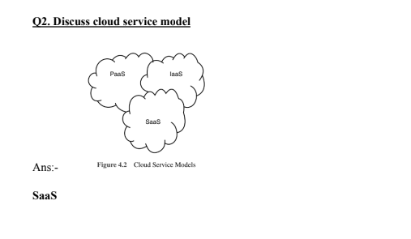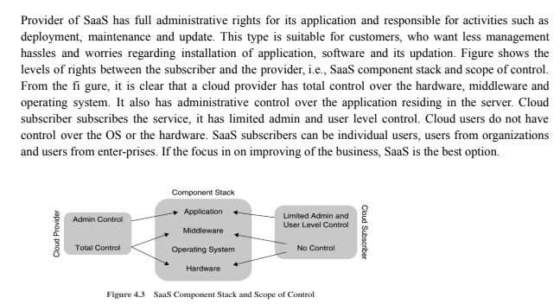

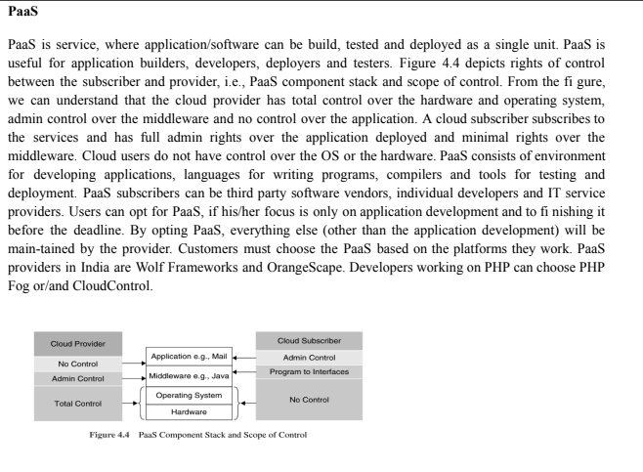

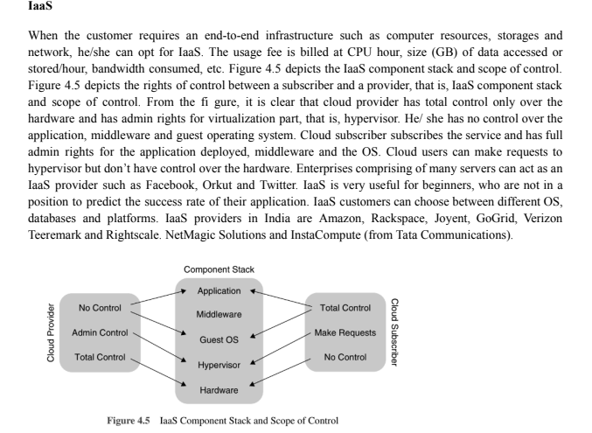

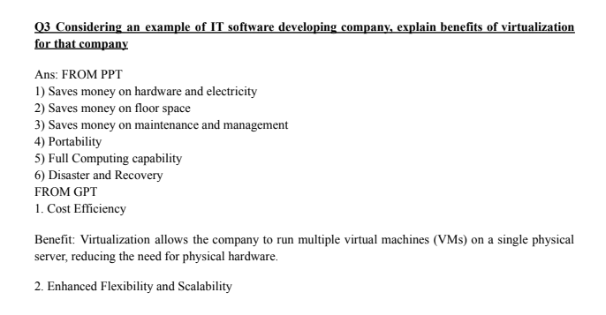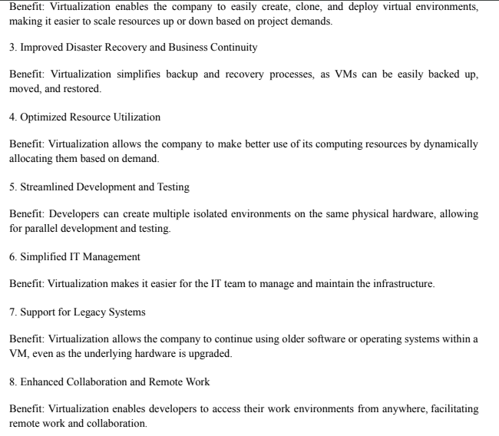

Explain Openstack architecture in detail

[OpenStack](https://www.javatpoint.com/openstack) is an open-standard and free platform for cloud computing. Mostly, it is deployed as [**IaaS** (Infrastructure-as-a-Service)](https://www.javatpoint.com/openstack) in both private and public clouds where various virtual servers and other types of resources are available for users. This platform combines irrelated components that networking resources, storage resources, multi-vendor hardware processing tools, and control diverse throughout the data center. Various users manage it by the command-line tools, [RESTful web services](https://www.javatpoint.com/restful-web-services), and web-based dashboard.In 2010, OpenStack began as the joint project of **NASA** and **Rackspace Hosting**. It was handled by the **OpenStack Foundation** which is a non-profit collective entity developed in 2012 September for promoting the OpenStack community and software. 50+ enterprises have joined this project.

Unlike virtualization, in which resources such as RAM, CPU, etc are abstracted from the hardware using hypervisors, OpenStack uses a number of APIs to abstract those resources so that users and the administrators are able to directly interact with the cloud services.

Components:

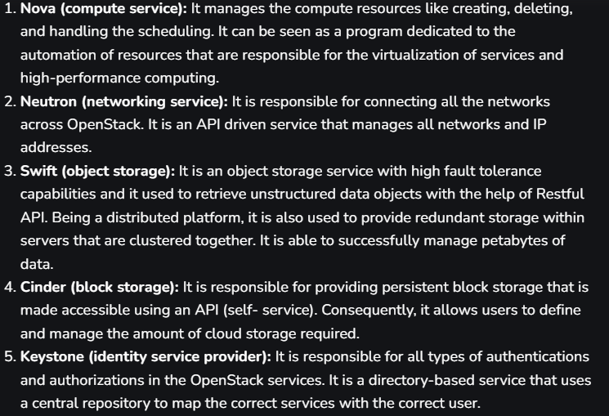 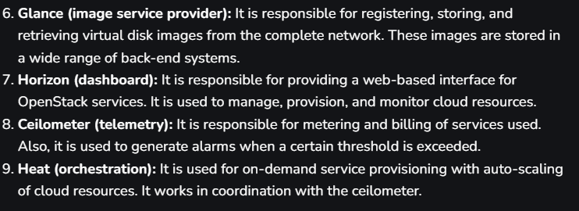

<https://www.javatpoint.com/openstack-architecture>

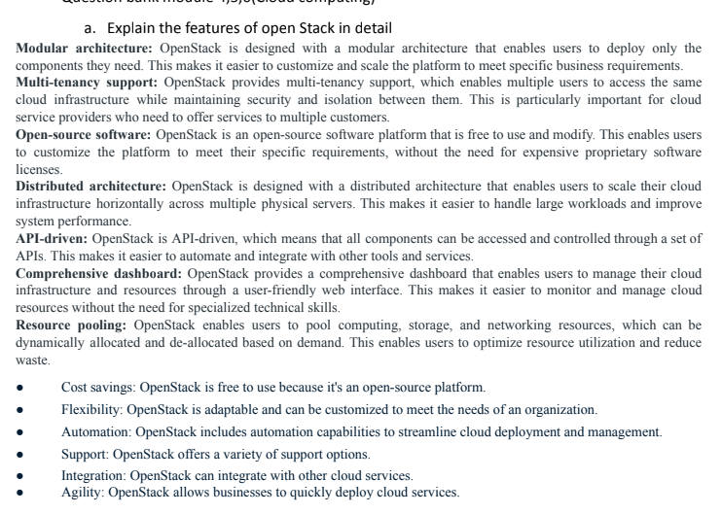

Explain saas with example

<https://www.javatpoint.com/software-as-a-service>

<https://www.javatpoint.com/infrastructure-as-a-service>

<https://www.javatpoint.com/platform-as-a-service>

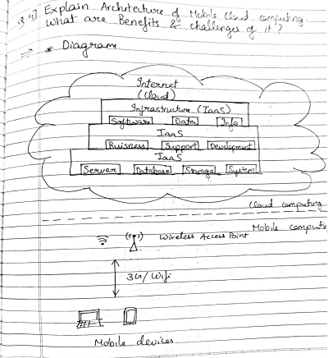

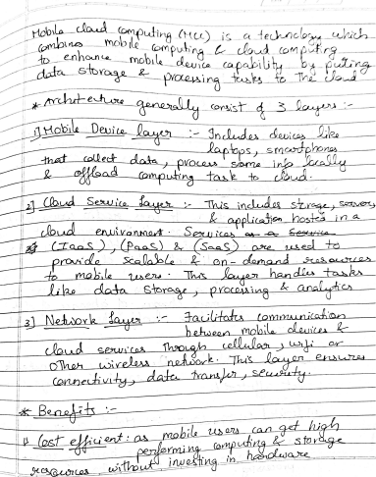

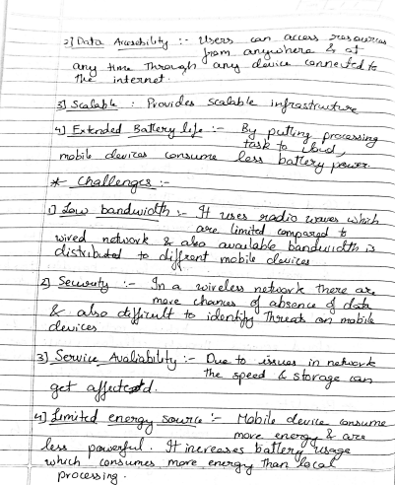

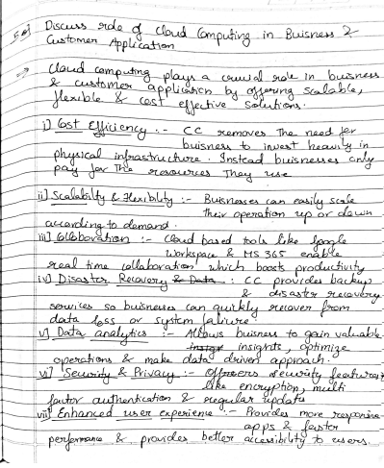

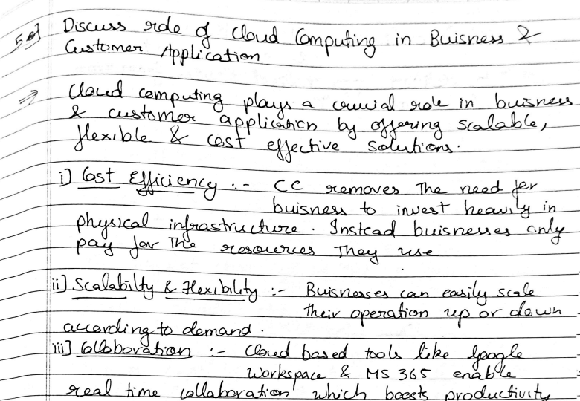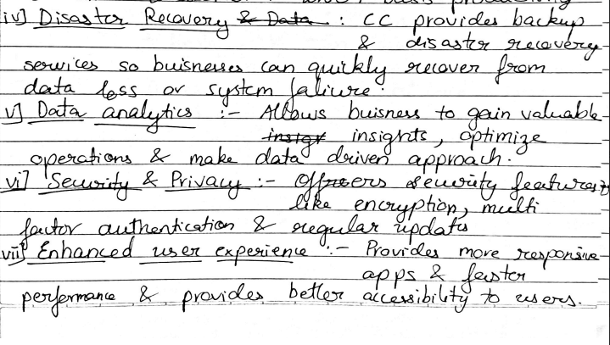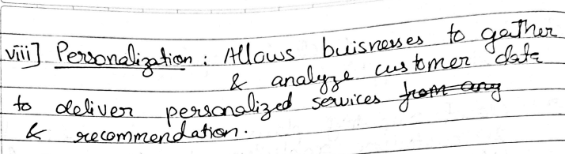

<https://www.javatpoint.com/cloud-computing-applications>

different inmplementation levels of vitrualization

In recent times, it is not sufficient to use just a single software in computing. Today professionals look to test their software and program across various platforms. However, there are challenges here because of varied constraints. This gives rise to the concept of virtualization. Virtualization lets the users create several platform instances, which could be various applications and operating systems.

Virtualization is not a new concept. It has existed since 1960; however, it is only now, thanks to the cloud-based systems, that there has been a lot of attention given to the implementation of virtualization in Cloud Computing. It is the capacity that lets you run many computer system instances using the same hardware set. How you use the hardware can be varied, which is based on how the virtual machine is configured.

A very amazing yet simple example of virtualization is your PC or your laptop. You run Windows on your laptop, but thanks to virtualization, you can also run Ubuntu on our laptop today.

**Implementation Levels of Virtualization In Cloud Computing**

 It is not simple to set up virtualization. Your computer runs on an operating system that gets configured on some particular hardware. It is not feasible or easy to run a different operating system using the same hardware.

To do this, you will need a hypervisor. Now, what is the role of the hypervisor? It is a bridge between the hardware and the virtual operating system, which allows smooth functioning.

Talking of the Implementation levels of virtualization in Cloud Computing., there area total of five levels that are commonly used. Let us now look closely at each of these levels of virtualization implementation in Cloud Computing.

**1) Instruction Set Architecture Level (ISA)**

ISA virtualization can work through ISA emulation. This is used to run many legacy codes written for a different hardware configuration. These codes run on any virtual machine using the ISA. With this, a binary code that originally needed some additional layers to run is now capable of running on the x86 machines. It can also be tweaked to run on the x64 machine. With ISA, it is possible to make the virtual machine hardware agnostic.

For the basic emulation, an interpreter is needed, which interprets the source code and then converts it into a hardware format that can be read. This then allows processing. This is one of the five implementation levels of virtualization in Cloud Computing..

**2) Hardware Abstraction Level (HAL)**

True to its name HAL lets the virtualization perform at the level of the hardware. This makes use of a hypervisor which is used for functioning. The virtual machine is formed at this level, which manages the hardware using the virtualization process. It allows the virtualization of each of the hardware components, which could be the input-output device, the memory, the processor, etc.Multiple users will not be able to use the same hardware and also use multiple virtualization instances at the very same time. This is mostly used in the cloud-based infrastructure.

**3) Operating System Level**

At the level of the operating system, the virtualization model is capable of creating a layer that is abstract between the operating system and the application. This is an isolated container on the operating system and the physical server, which uses the software and hardware. Each of these then functions in the form of a server. When there are several users and no one wants to share the hardware, then this is where the virtualization level is used. Every user will get his virtual environment using a dedicated virtual hardware resource. In this way, there is no question of any conflict.

**4) Library Level**

The operating system is cumbersome, and this is when the applications use the API from the libraries at a user level. These APIs are documented well, and this is why the library virtualization level is preferred in these scenarios. API hooks make it possible as it controls the link of communication from the application to the system.

**5) Application Level**

The application-level virtualization is used when there is a desire to virtualize only one application and is the last of the implementation levels of virtualization in Cloud Computing. One does not need to virtualize the entire environment of the platform. This is generally used when you run virtual machines that use high-level languages. The application will sit above the virtualization layer, which in turn sits on the application program.It lets the high-level language programs compiled to be used at the application level of the virtual machine run seamlessly.

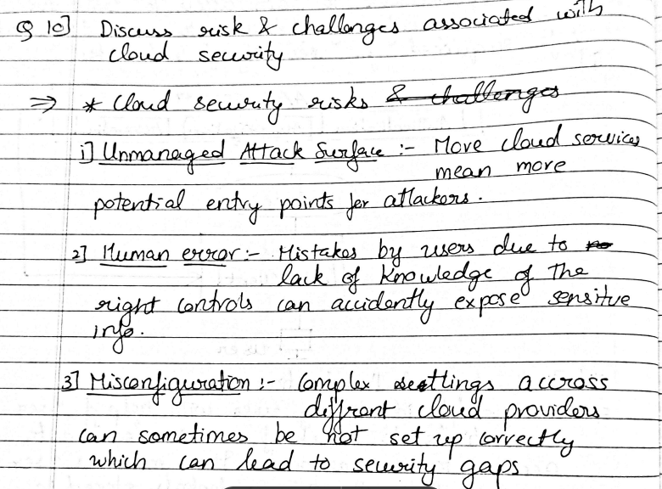

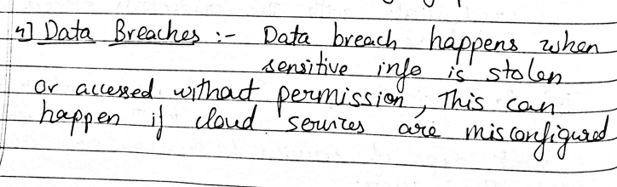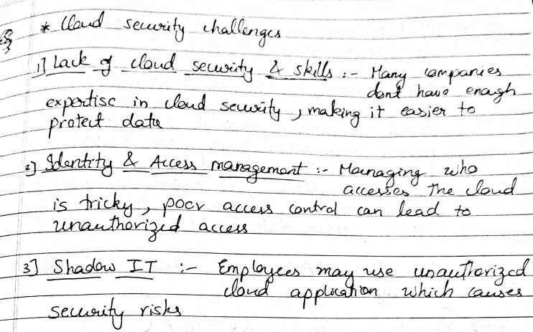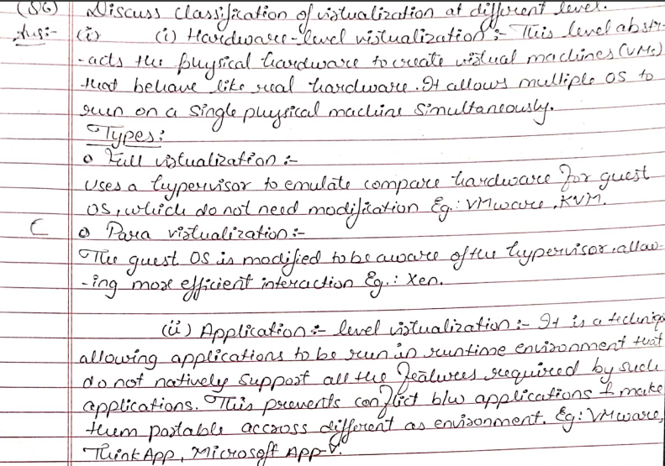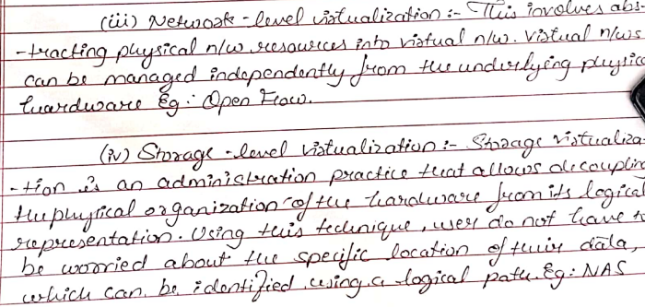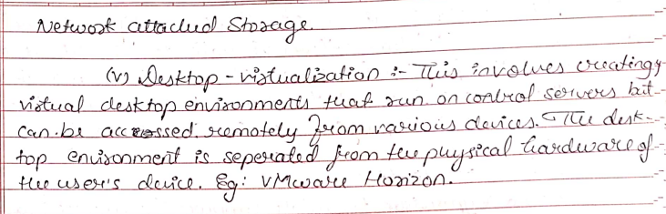

<https://bcalabs.org/subject/taxonomy-of-virtualization-techniques-in-cloud-computing>

Explain Storage as a service and collaboration as a services

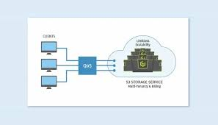

STaaS stands for storage as a service. It is a cloud business model in which a company rents its storage area infrastructure to another company or individuals to store the data. The storage provider provides the client with the software required to access their stored data. STaaS eliminates the need for users to purchase and maintain their own storage infrastructure. STaaS providers offer a range of storage options based on the amount of data, type of data, and level of security required. The storage can be provided in the form of file, block, or object storage, depending on the need. STaaS provides advanced data management features such as data encryption, backup, replication, and disaster recovery. STaaS allows users to easily increase or decrease the amount of storage capacity they need depending on their business needs. STaaS is cost-effective, as users only pay for the storage capacity they use. STaaS providers offer advanced security features such as data encryption, access control, and thread detection, which help to protect data from unauthorized access and cyber threats. STaaS providers also offer backup and disaster recovery options, ensuring that data is always available even in the event of a data loss.

Storage System in cloud

Block-based storage system: This type of storage system organizes data into fixed-sized blocks, which are typically accessed at a low level by the operating system or applications

* It resembles cloud-based hard drives.
* It involves volume partitioning and formatting.
* Provides direct access to drives, volumes and partitions.

File-based storage system: Unlike block-based systems, file-based storage systems organize data into files and folders.

* Utilize Network-Attached Storage (NAS) devices.
* Facilitates file sharing over the network.
* Simplifies storage access over the network.

Objective-based storage system: This type of storage system treats data as objects rather than files or blocks.

* Utilizes HTTP protocols and REST APIs for data operations.
* Prioritizes simplicity and accessibility.
* Offers a flat structure for objects and files.

Uses of STaaS

STaaS can be utilized by enterprises for various purposes such as data transfers, redundant storage and data recovery in case of data corruption or loss. Here we will see some more such use cases of STaaS.

Data Backup and Recovery: STaaS provides better solution for data backup and recovery. Various enterprises can use it to automatically back up critical data and quickly restore it in case of data loss or corruption.

Entertainment and Media: It is used in media and entertainment industry for storing and managing large media files, such as video, images and autio files. It allow then for efficient distribution and management of data.

Scalable Storage: STaaS can be used by various enterprises to scale their storage infrastructure according to their needs. It helps in handling the fluctuating storage demands without investing in additional hardware.

Disaster Recovery: STaaS can be used in case of any disaster recovery. It allow efficient storage for various organizations to replicate their data to remote locations for data redundancy. Which will help them in future in case of any disaster to recover their data.

Popular STaaS providers

Here are some popular STaaS (Storage as a Service) providers:

* Amazon S3 (Simple Storage Service)
* Microsoft Azure Blob Storage
* Google Cloud Storage
* Dropbox
* OneDrive
* Box
* iCloud

Advantages of STaaS

Key advantages of STaaS are as follow:

* Accessibility from anywhere with an internet connection.
* Scalability to meet changing data storage needs.
* Cost-effectiveness with pay-as-you-go pricing.
* Data redundancy and high reliability.
* Automatic backup and recovery features.
* Easy collaboration and file sharing.

Disadvantages of STaaS

* Dependency on internet connection.
* In some cases data access may be slower as compare to on-premises storage.
* Integrating STaaS with existing IT infrastructure and applications can be complex.
* Users have limited control over the storage infrastrucutre in STaaS.

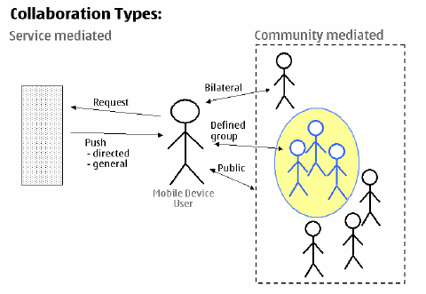

### Collaboration as a Service (CaaS)

**Introduction**  
Collaboration as a Service (CaaS) is a cloud-based model that provides organizations with tools and platforms to enable seamless collaboration among team members, regardless of their physical location. It encompasses a variety of software applications and services, such as video conferencing, instant messaging, document sharing, and project management tools. CaaS helps organizations improve productivity, communication, and teamwork by offering scalable and cost-effective solutions.

### ****Types of Collaboration as a Service****

1. **Communication Platforms**  
   Services that facilitate real-time communication, such as:
   * Video conferencing (e.g., Zoom, Microsoft Teams).
   * Instant messaging (e.g., Slack, Google Chat).
2. **Document Management and Sharing**  
   Tools for collaborative document creation, editing, and sharing, such as:
   * Google Workspace.
   * Microsoft 365.
3. **Project Management Tools**  
   Platforms for managing tasks and workflows, such as:
   * Trello.
   * Asana.
   * Monday.com.
4. **Social Collaboration Tools**  
   Applications that enhance social interaction within an organization, such as:
   * Workplace by Meta.
   * Yammer.
5. **Specialized Collaboration Services**  
   Industry-specific tools tailored for particular needs, such as:
   * GitHub for developers.
   * Figma for design teams.

### ****Uses of Collaboration as a Service****

* **Remote Work Enablement:** Allows teams to collaborate effectively across different geographies.
* **Team Communication:** Facilitates real-time communication and feedback.
* **Document Sharing and Co-editing:** Enables multiple users to work on the same document simultaneously.
* **Task and Workflow Management:** Organizes tasks, deadlines, and priorities for teams.
* **Knowledge Sharing:** Provides a centralized repository for information and resources.
* **Customer Interaction:** Supports customer communication through integrated platforms.

### ****Key Providers of Collaboration as a Service****

1. **Microsoft Teams**  
   Comprehensive platform offering chat, video calls, and document collaboration.
2. **Slack**  
   Focuses on instant messaging and integrations with other tools.
3. **Zoom**  
   Specializes in video conferencing and webinars.
4. **Google Workspace**  
   Provides tools like Google Drive, Docs, Sheets, and Meet for seamless collaboration.
5. **Trello and Asana**  
   Focus on task and project management.

### ****Advantages of Collaboration as a Service****

1. **Scalability:** Easily scalable to meet the needs of small or large organizations.
2. **Cost Efficiency:** Reduces the need for on-premises infrastructure.
3. **Flexibility:** Offers access to tools from anywhere with an internet connection.
4. **Improved Productivity:** Streamlines workflows and reduces communication gaps.
5. **Integration:** Compatible with various third-party applications and tools.
6. **Enhanced Security:** Provides encrypted and secure communication channels.

### ****Disadvantages of Collaboration as a Service****

1. **Dependency on Internet:** Requires stable internet connectivity.
2. **Data Privacy Concerns:** Involves storing sensitive information on third-party servers.
3. **Learning Curve:** May require training for effective use of advanced features.
4. **Downtime Risks:** Vulnerable to service outages that disrupt collaboration.
5. **Cost Over Time:** Subscription-based models can become expensive for prolonged use.
6. **Limited Customization:** May not fully cater to unique organizational needs.

### ****Applications of Collaboration as a Service****

1. **Corporate Workplaces:** Enhances team productivity and project management.
2. **Education:** Enables online learning and collaboration between students and educators.
3. **Healthcare:** Facilitates coordination among medical professionals and patient management.
4. **Creative Industries:** Supports designers and developers with specialized tools.
5. **Customer Support:** Provides real-time communication for resolving customer queries.
6. **Government and Nonprofits:** Assists in coordination and outreach programs.

By integrating Collaboration as a Service into their workflows, organizations can achieve greater efficiency, enhanced communication, and a collaborative environment that fosters innovation.

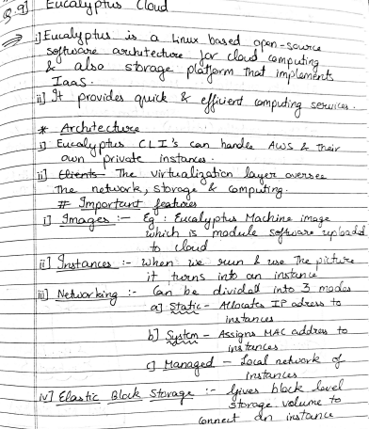

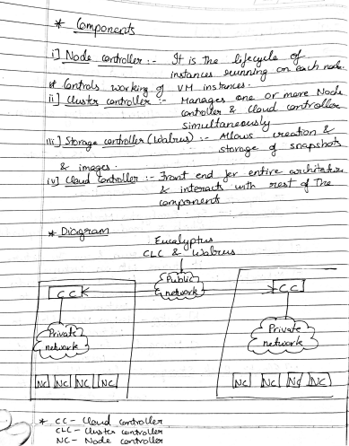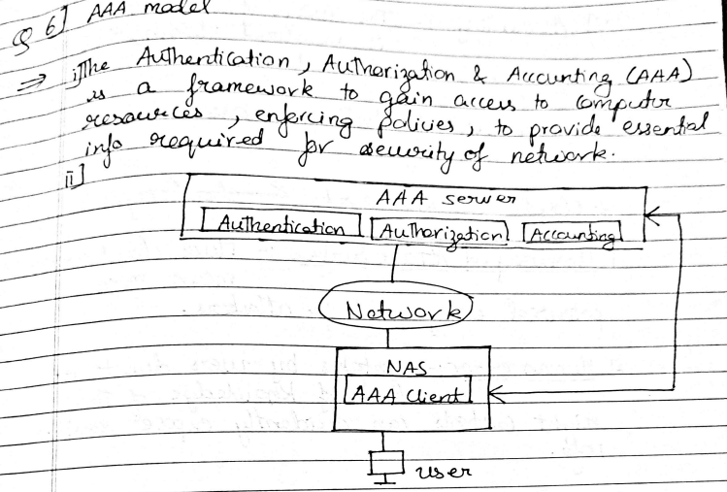

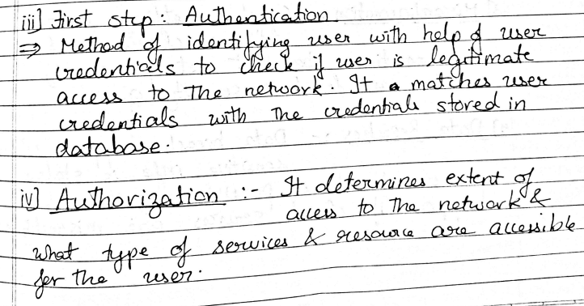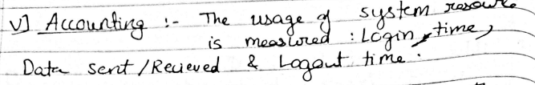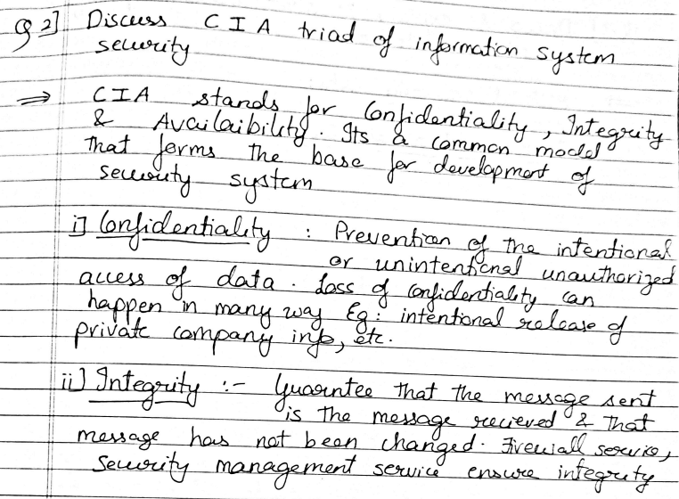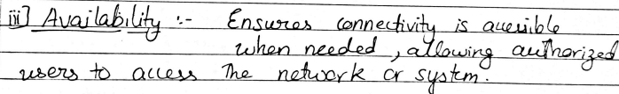

ECG: https://www.includehelp.com/cloud-computing/healthcare-ecg-analysis-in-the-cloud.aspx

Everything as a service

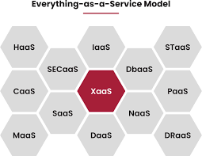

### Everything as a Service (XaaS)

**Introduction**  
Everything as a Service (XaaS) is a cloud computing paradigm that extends the concept of delivering services over the internet to almost anything—be it software, infrastructure, or even specialized tools. Initially, cloud computing primarily offered basic services like storage or computing power. However, with XaaS, nearly every aspect of IT and business processes can now be offered as a service. It leverages cloud computing and remote access, enabling businesses to use and pay for only the services they need without investing in physical infrastructure or licenses. This model simplifies IT deployments, reduces costs, and enhances scalability. XaaS is also known as Anything as a Service.

### ****Examples of XaaS****

XaaS encompasses a broad range of services, including but not limited to:

1. **Software as a Service (SaaS)**
   * Examples: Google Workspace, Microsoft Office 365.
   * Provides software applications accessible via the internet without the need for installation.
2. **Platform as a Service (PaaS)**
   * Examples: AWS Elastic Beanstalk, Heroku, Apache Stratos.
   * Offers a platform for application development, testing, and deployment.
3. **Infrastructure as a Service (IaaS)**
   * Examples: Microsoft Azure, Google Compute Engine.
   * Delivers virtualized computing resources over the internet.
4. **Disaster Recovery as a Service (DRaaS)**
   * Examples: Veeam Cloud Connect, Carbonite.
   * Ensures data recovery and business continuity during disasters.
5. **Communication as a Service (CaaS)**
   * Examples: Zoom, Slack.
   * Facilitates real-time communication through VoIP, video conferencing, and messaging.
6. **Database as a Service (DBaaS)**
   * Examples: Amazon RDS, MongoDB Atlas.
   * Provides database services for storage, management, and access.
7. **Desktop as a Service (DaaS)**
   * Examples: Citrix, VMware Horizon Cloud.
   * Offers virtual desktop environments managed by a third-party provider.

### ****Everything as a Service Model Examples****

1. **Hardware as a Service (HaaS)**  
   Managed Service Providers (MSPs) install and maintain hardware at the client’s location based on service agreements.
   * **Example:** Renting servers or routers for temporary projects.
2. **Communication as a Service (CaaS)**  
   Provides hosted solutions for communication needs, saving costs and time.
   * **Example:** VoIP services like RingCentral.
3. **Desktop as a Service (DaaS)**  
   Enables users to access desktops through third-party servers.
   * **Example:** Virtual desktops for remote work environments.
4. **Security as a Service (SECaaS)**  
   Integrates security tools via the internet, including antivirus, authentication, and encryption.
   * **Example:** Cloudflare for DDoS protection.
5. **Healthcare as a Service (HaaS)**  
   Revolutionizes healthcare with electronic medical records (EMR) and IoT-enabled devices.
   * **Example:** Telemedicine platforms like Practo.
6. **Transport as a Service (TaaS)**  
   Supports on-demand mobility through apps, promoting eco-friendly solutions.
   * **Example:** Uber's ride-sharing services.

### ****Benefits of XaaS****

1. **Cost Saving**  
   Eliminates the need for expensive infrastructure and licenses.
   * Example: SaaS applications reduce upfront software costs.
2. **Scalability**  
   Provides resources dynamically as business demands grow.
   * Example: IaaS scaling server capacity during traffic spikes.
3. **Accessibility**  
   Services are accessible from anywhere with internet connectivity.
   * Example: Remote employees accessing virtual desktops.
4. **Faster Implementation**  
   Reduces deployment times for IT services.
   * Example: Deploying SaaS tools like CRM systems within hours.
5. **Quick Modifications**  
   Enables rapid updates and feature enhancements.
   * Example: Automatic updates in Google Workspace apps.
6. **Better Security**  
   Offers advanced security configurations tailored to business needs.
   * Example: SECaaS providing 24/7 monitoring and threat detection.
7. **Boosts Innovation**  
   Frees up resources for R&D by streamlining operations.
   * Example: Using PaaS for agile app development.
8. **Flexibility**  
   Allows businesses to mix and match services as needed.
   * Example: Combining IaaS, SaaS, and DBaaS for an e-commerce platform.

### ****Disadvantages of XaaS****

1. **Internet Dependency**  
   Requires a stable internet connection for uninterrupted service.
   * Example: Work disruptions during network outages.
2. **System Slowdowns**  
   High demand from multiple users may degrade performance.
   * Example: Overloaded servers during peak hours.
3. **Troubleshooting Complexity**  
   Diagnosing issues becomes challenging with diverse services.
   * Example: Identifying the root cause of an application failure in a complex XaaS environment.
4. **Change Management Issues**  
   Service discontinuation or alterations impact users significantly.
   * Example: Migration challenges when a provider stops supporting a service.

### ****XaaS on the Rise****

Public cloud services are growing exponentially. Research predicts global cloud computing revenue will surpass **$342 billion by 2025**. The XaaS model enables businesses to innovate faster by combining services and products, enhancing customer relationships and revenue streams.

### ****Future of XaaS****

With improvements in cloud computing and internet connectivity, XaaS adoption is expected to grow. Concerns around security and governance are being actively addressed by providers, encouraging organizations to transition more workloads to the cloud. The future of XaaS holds immense potential in transforming industries and enabling new business models.

This comprehensive understanding of XaaS highlights its transformative impact on businesses, showcasing how it simplifies operations, enhances scalability, and drives innovation across sectors.

### ****Cloud Backup Solutions and Features****

**Introduction**  
Cloud backup solutions are services that enable users and organizations to back up their data to remote cloud-based servers. These solutions protect critical data from potential loss due to hardware failures, natural disasters, cyberattacks, or accidental deletions. They ensure the availability and accessibility of data from anywhere with an internet connection. Cloud backup is an integral part of modern data management strategies, offering scalability, security, and automation.

### ****Key Features of Cloud Backup Solutions****

1. **Automated Backups**
   * Schedules backups at regular intervals without manual intervention.
   * Example: Daily automatic backups for critical files.
2. **Scalability**
   * Expands storage capacity as needed to accommodate growing data volumes.
   * Example: Cloud providers like AWS S3 dynamically adjust storage based on demand.
3. **Data Encryption**
   * Ensures secure data transmission and storage using encryption protocols.
   * Example: AES-256 encryption for sensitive business data.
4. **Disaster Recovery**
   * Facilitates quick recovery of data after unexpected incidents.
   * Example: Restoring company databases after a ransomware attack.
5. **Versioning and Retention**
   * Maintains multiple versions of files, enabling rollback to earlier states.
   * Example: Restoring a previous version of a document after accidental changes.
6. **Cross-Platform Support**
   * Works across different devices and operating systems (Windows, macOS, Linux).
   * Example: Syncing files from desktop, laptop, and mobile devices.
7. **Incremental Backups**
   * Backs up only changed or new data since the last backup to save time and bandwidth.
   * Example: Updating backup files with only modified sections.
8. **Redundancy**
   * Stores data across multiple data centers to ensure availability even in case of server failures.
   * Example: Geo-redundant storage in Microsoft Azure.
9. **Access Controls and Permissions**
   * Provides user-specific access levels to enhance data security.
   * Example: Restricting access to financial records to authorized personnel.
10. **Real-Time Monitoring and Alerts**
    * Offers dashboards and notifications for backup status and issues.
    * Example: Alerting users about failed backup attempts.
11. **Cost Management and Transparency**
    * Provides clear pricing models and monitoring tools for cost control.
    * Example: Pay-as-you-go plans with detailed usage breakdowns.
12. **Mobile Accessibility**
    * Enables backup management and data retrieval through mobile apps.
    * Example: Managing backups on the go via a smartphone app.
13. **Data Deduplication**
    * Eliminates duplicate data to optimize storage usage and costs.
    * Example: Storing only one copy of identical files.
14. **Customizable Backup Policies**
    * Allows users to set specific backup rules based on data type and priority.
    * Example: Weekly backups for archives, daily for active projects.

### ****Benefits of Cloud Backup Solutions****

1. **Data Security:** Ensures that data is protected from unauthorized access and cyber threats.
2. **Cost-Effectiveness:** Eliminates the need for physical storage and maintenance.
3. **Ease of Use:** Provides intuitive interfaces for managing backups effortlessly.
4. **Global Accessibility:** Allows data access and recovery from anywhere.
5. **Business Continuity:** Minimizes downtime by ensuring quick recovery in emergencies.

### ****Popular Cloud Backup Solutions****

1. **Acronis Cyber Protect**
   * Combines backup with cybersecurity features like ransomware protection.
2. **Carbonite**
   * Offers automated, unlimited cloud storage with file recovery features.
3. **Veeam Backup & Replication**
   * Enterprise-grade solution for hybrid and multi-cloud environments.
4. **Backblaze**
   * Affordable and user-friendly cloud backup service for individuals and businesses.
5. **IDrive**
   * Provides cross-platform support with features like file syncing and sharing.
6. **Google Cloud Backup and DR**
   * Integrated with Google Cloud services for seamless data protection.
7. **AWS Backup**
   * Centralized service for managing backups across AWS services.

### ****Applications of Cloud Backup Solutions****

1. **Small and Medium Enterprises (SMEs):** Cost-effective way to protect critical data.
2. **Healthcare:** Safeguards sensitive patient data in compliance with regulations.
3. **Education:** Protects student records and academic materials.
4. **E-commerce:** Ensures data continuity for transactions and customer information.
5. **Remote Work:** Provides secure backup for distributed workforce data.

Cloud backup solutions are indispensable in today’s digital age, ensuring data security, accessibility, and continuity for businesses and individuals alike.